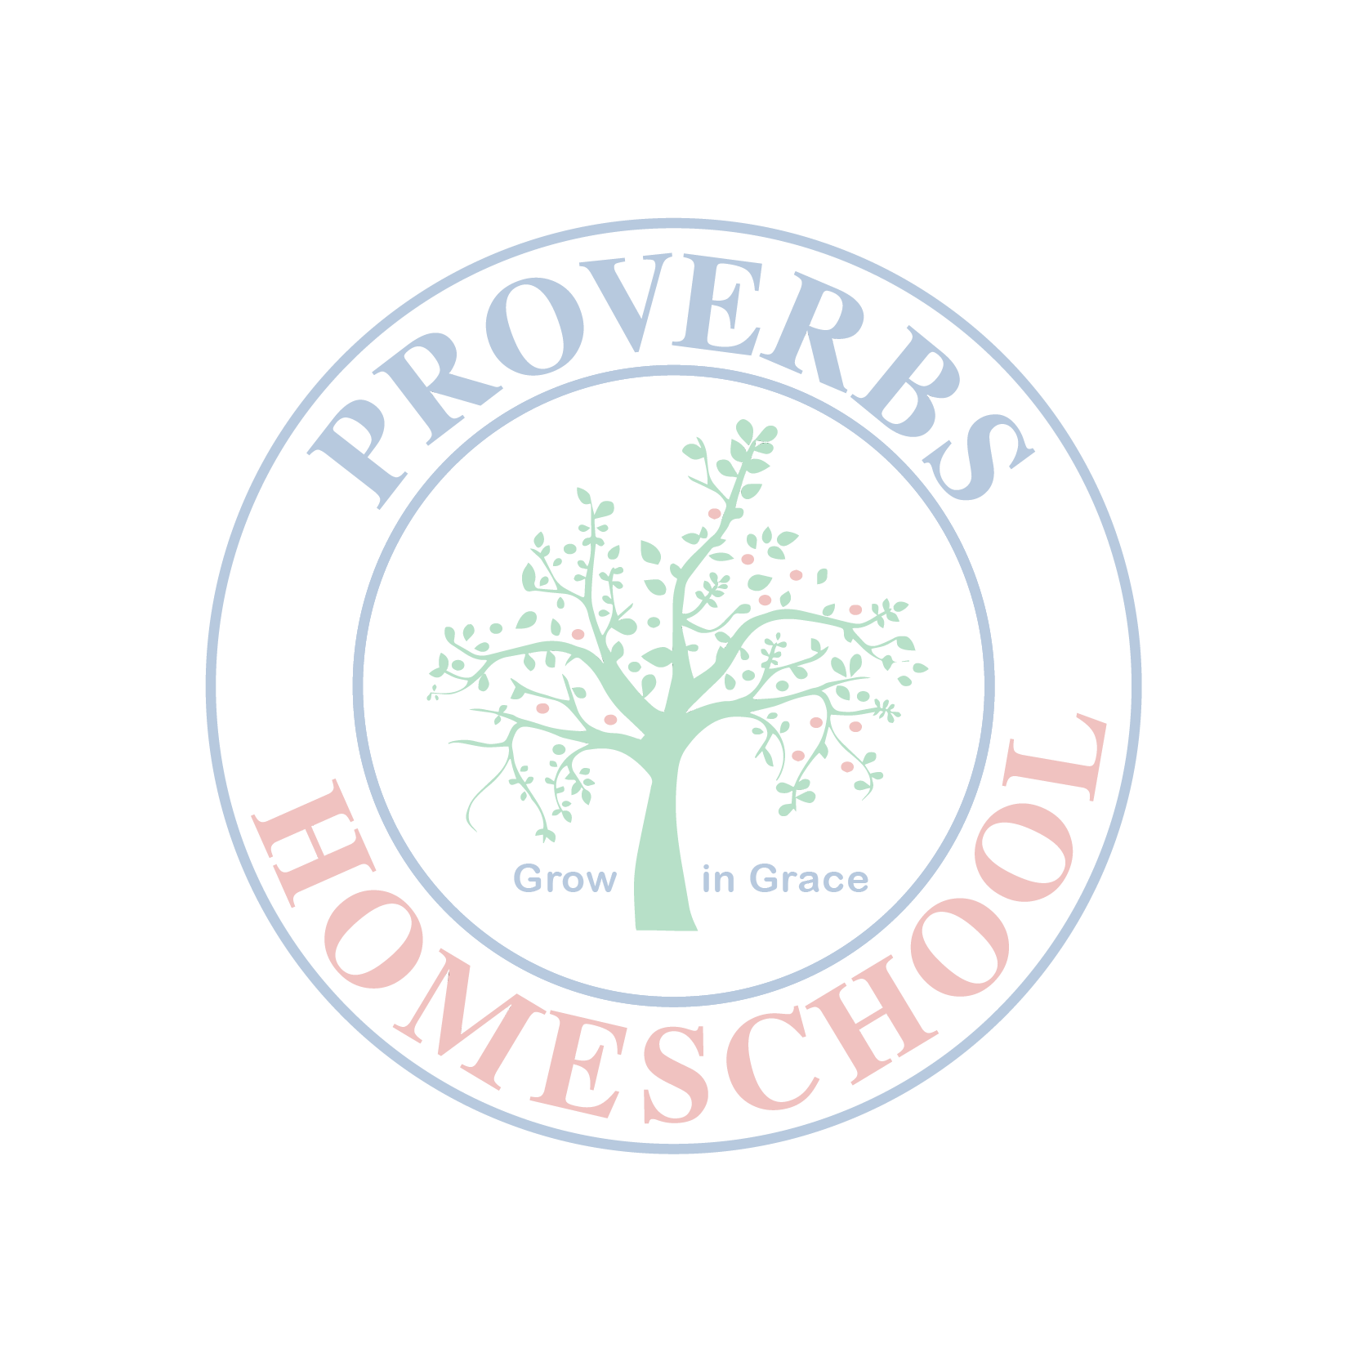
CERTIFICATE OF ACHIEVEMENT
Proverbs Homeschool presents the

(TITLE OF AWARD)

to

(Name of Child)
_________________________________________________________________________________________________________________________________________________________

in recognition of his/her exemplary performance for S.Y. 2020-2021
given this 30th of June 2021 in Manila, Philippines

____________________________ _____Glenda J. Magtoto____
Parent – Teacher Principal

“I Can do all things through Christ who strengthens me.” Philippians 4:13

